|  |
| --- |
|  |
| Screen Specification |
| For use case Log in |
|  |
| **Doan Ngoc Giang Nam** |
| **10/10/2017** |

Brieft specification of use case log in interface designs

Table of Contents

1. Pages 3

1.1. Page Tree 3

1.2. Homepage 4

1.2.1. User Interface 4

1.2.2. Widget Table 4

1.3. Log in 5

1.3.1. User Interface 5

1.3.2. Widget Table 5

1.4. Register 7

1.4.1. User Interface 7

1.4.2. Widget Table 7

1.5. Log in Success 8

1.5.1. User Interface 8

1.5.2. Widget Table 8

2. Defining the field attribute.....................................................................................................................................................................9

1. Pages
   1. Page Tree

use_case_log_in  
 Homepage  
 Log in  
 Register  
 Log in Success

* 1. Homepage
     1. User Interface

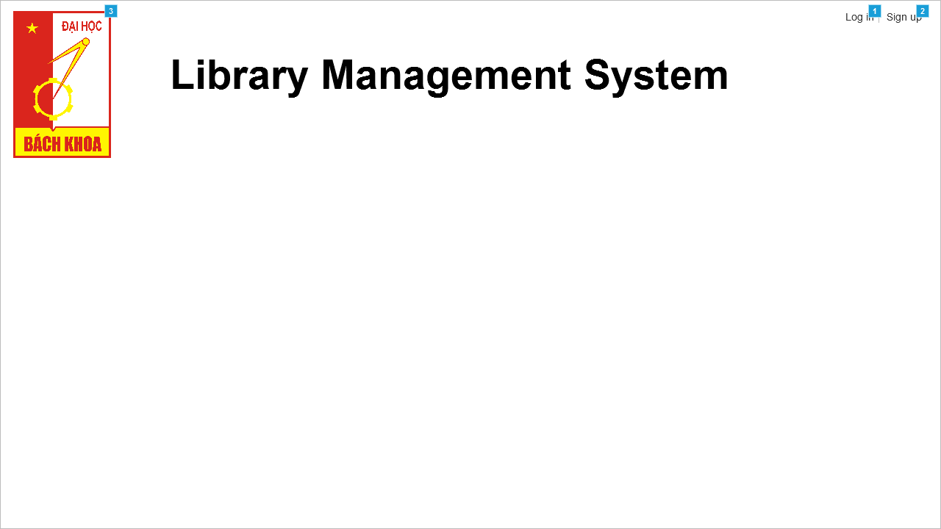

* + 1. Widget Table

|  |  |  |
| --- | --- | --- |
| **Footnote** | **Name** | **Interactions** |
| 1 | Log in | OnClick:  Case 1:  Open Log in in Current Window |
| 2 | Sign up | OnClick:  Case 1:  Open Register in Current Window |
| 3 | Bach Khoa Logo | OnClick:  Case 1:  Open Homepage in Current Window |

* 1. Log in
     1. User Interface

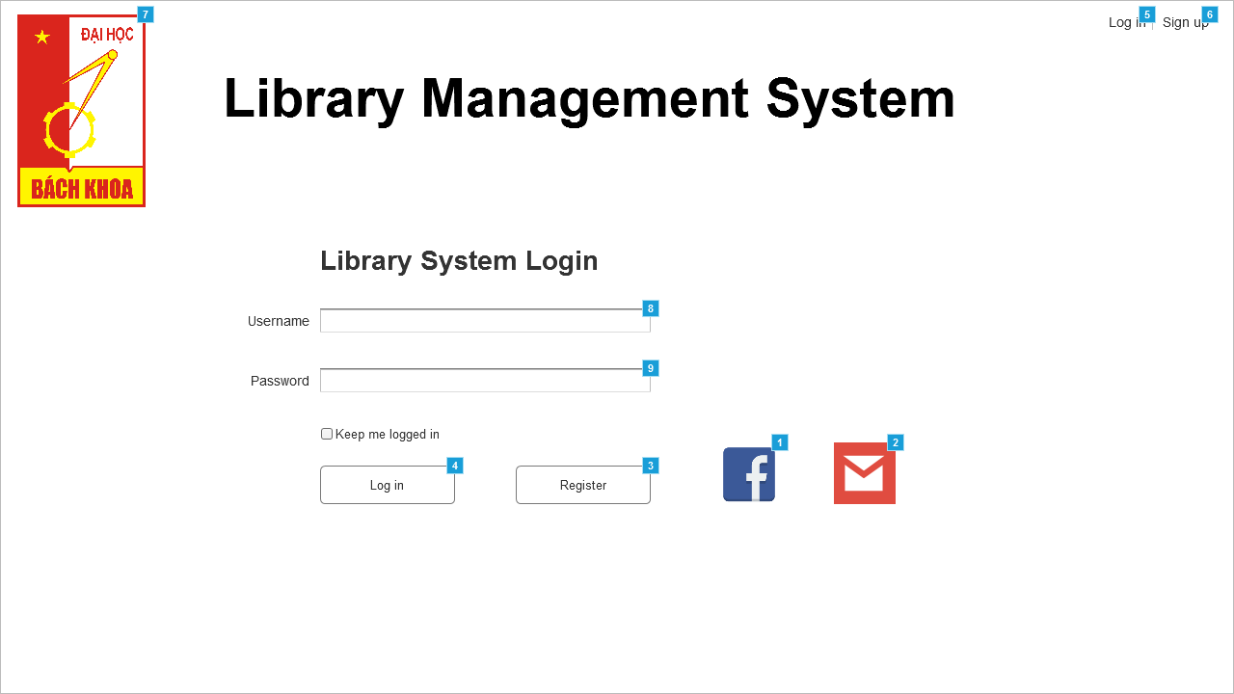

* + 1. Widget Table

|  |  |  |  |
| --- | --- | --- | --- |
| **Footnote** | **Name** | **Interactions** | **Note** |
| 1 | Facebook logo | OnMouseEnter:  Case 1:  Show (Rectangle) OnMouseOut:  Case 1:  Hide (Rectangle) | show hover tooltip |
| 2 | Gmail logo | OnMouseEnter:  Case 1:  Show (Rectangle) OnMouseOut:  Case 1:  Hide (Rectangle) | show hover tooltip |
| 3 | Register button | OnClick:  Case 1:  Open Register in Current Window | Navigate to register screen |
| 4 | Login button | OnClick:  Case 2  (If text on Password equals "" and text on Username equals ""):  Show (Rectangle), (Rectangle)  Case 3  (Else If text on Username equals "" and text on Password does not equal ""):  Show (Rectangle)  Case 4  (Else If text on Password equals "" and text on Username does not equal ""):  Show (Rectangle)  Case 1  (Else If text on Password does not equal "" and text on Username does not equal ""):  Open Log in Success in Current Window | If one of the text fields (or both) is empty, click on this will display the warning message. Otherwise, it will navigate to user homepage |
| 5 | Log in | OnClick:  Case 1:  Open Log in in Current Window | Navigate to log in screen |
| 6 | Sign up | OnClick:  Case 1:  Open Register in Current Window | Navigate to register screen |
| 7 | Bach Khoa logo | OnClick:  Case 1:  Open Homepage in Current Window | Click on this logo will go back to the homepage |
| 8 | Username |  | text field to type in username of an user |
| 9 | Password |  | text field to type in password of an user |

* 1. Register
     1. User Interface



* + 1. Widget Table

|  |  |  |
| --- | --- | --- |
| **Footnote** | **Name** | **Interactions** |
| 1 | Log in | OnClick:  Case 1:  Open Log in in Current Window |
| 2 | Sign up | OnClick:  Case 1:  Open Register in Current Window |
| 3 | Bach Khoa logo | OnClick:  Case 1:  Open Homepage in Current Window |

* 1. Log in Success
     1. User Interface

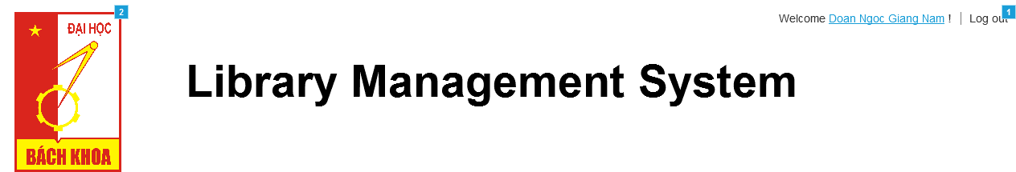

* + 1. Widget Table

|  |  |
| --- | --- |
| **Footnote** | **Interactions** |
| 1 | OnClick:  Case 1:  Open Homepage in Current Window |
| 2 | OnClick:  Case 1:  Open Log in Success in Current Window |

**2. Defining the field attribute (for 1.3 log in screen)**

|  |  |  |  |  |
| --- | --- | --- | --- | --- |
| Item name | Number of digits(bytes) | Type | Field attribute | Remarks |
| Username | Greater than 7 | Character | White(red error message) | Display red error message when submitting empty field |
| Password | Greater than 5 | Password format (array of *) | White(red error message) | Display red error message when submitting empty field |